[](https://www.google.com.tr/url?sa=i&rct=j&q=&esrc=s&source=images&cd=&cad=rja&uact=8&ved=2ahUKEwiLtbbNibPfAhUwzYUKHcxnBWMQjRx6BAgBEAU&url=https://ficardo-weddings.com/file/pile-of-leaves-coloring-pages_2571059.html&psig=AOvVaw2h9hVRmt3ThOks0ncXykot&ust=1545555634646679)

**“ENGLISH IS FUN”**

**Hüseyin Pehlivan Primary School**

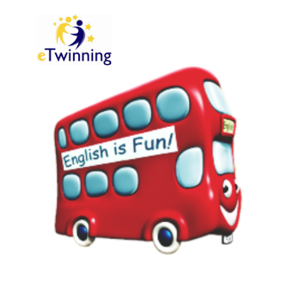****

**eTwinning**

**Yearly Calendar**